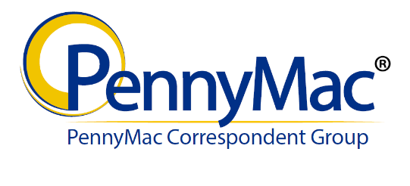

Correspondent Name______________________________ Date___________________________
Tracking Number _________________________________

For packages containing Allonges, Please address the package to:
Deutsche Bank National Trust Company
Attn: Team PennyMac/Funding
1761 E. Saint Andrews Place
Santa Ana, CA 92705

For packages containing Original Notes or Loan Modifications, Please address the package to:
Deutsche Bank National Trust Company
Attn: Team PennyMac/Correspondent
1761 E. Saint Andrews Place
Santa Ana, CA 92705

Please secure documents in sequential order per transmittal. You may ship multiple transmittal bundles within one package.
PNMAC Loan Number | Correspondent Loan Number | Borrower's Last Name | Document(s) | Received
For Document Custodian use only

Received By: ______________________________________ Date: __________________________________________
Printed Name

Signature ___________________________________________________________________________________________

Comments: __________________________________________________________________________________________

